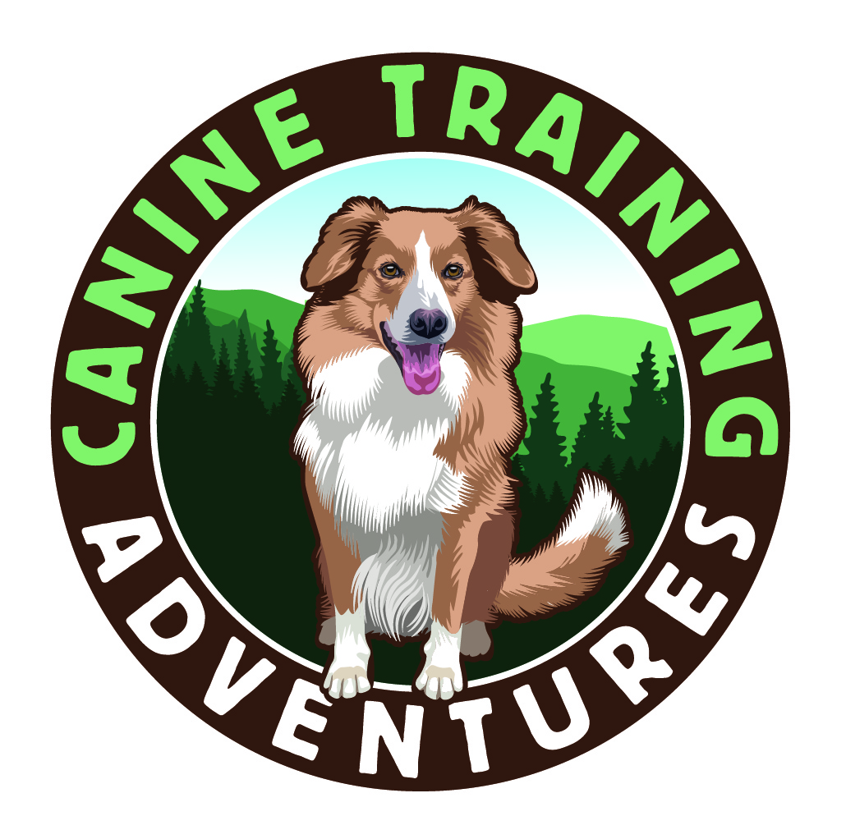
Canine Training Adventures
27058 Greenville Rd
Sweet Home OR 97386
541-409-1944
connie@caninetrainingadventures.com
www.caninetrainingadventures.com

Making Training a Fun and Rewarding Adventure!

Date____________

Name__________________________________________________________ Phone _____________________________________

Address________________________________________________________ City/Zip_____________________________________

Email Address_______________________________________________________________________________________________

Dogs Name_______________________________________ Age_________ Breed________________________________________

Male or Female___________________________________ Spayed or Neutered__________________________________________

Who is your veterinarian ______________________________________________________________________________________

Is your dog current on vaccinations according to your veterinarian’s recommendations? Yes / No.

How long have your owned your dog or puppy? ____________

Please list previous training experience of any?_____________________________________________________________________

___________________________________________________________________________________________________________

What class are you enrolling in? Class:________________________________ Date:____________________ Time:______________

What would you like to achieve from this class?____________________________________________________________________

___________________________________________________________________________________________________________

Waiver of Liability and Informed Consent Release - the Releasing Party and the undersigned, have enrolled myself and my dog in dog training classes, private lessons, workshops or other related activities (Classes) offered by Canine Training Adventure LLC, The Released Party. By checking the box below, I certify that I have been informed and understand that there is always some unavoidable risk of injury involved when working with animals, especially animals with behavioral issues. I acknowledge that dogs can be inherently difficult to control and that not all dogs will be under control at all times resulting in the possibility of injury to myself, my dog, my family members, or third parties. Additionally, I have had full opportunity to discuss all concerns I have about the foregoing risks with Canine Training Adventure and its authorized representatives. I have also made all inquiries and investigations to my satisfaction related to such risks, including, but not limited to, an examination of the training area (if applicable). I hereby accept and assume, without reservation, all risks associated with my participation in the Classes, including, but not limited to: the risks of any and all injuries to myself, my dog and any of my family members or third parties who may attend; the risks that my dog may cause injury to other persons and/or dogs while training. As lawful consideration for participating in the classes, I, for myself, my heirs, executors, administrators, legal representatives, successors and assigns hereby waive, release, discharge and agree not to sue and to indemnify, defend and hold harmless Caning Training Adventure LLC their members, managers, agents, and employees from any and all injuries, losses, claims and damages to any person or persons of any nature whatsoever, including claims arising from the Released Party’s own negligence, and all costs associated therewith, including attorney’s fees, court costs and consultant fees, arising from my participation in the Classes. This Waiver of Liability & Informed Consent Release shall be legally binding on the Releasing Party. Should the Releasing Party assert a claim to the contrary to what has been agreed to in this Waiver of Liability and Informed Consent Release, the claiming party shall be liable for all expenses (including attorney’s fees, court costs and consultant fees) incurred by both the Releasing Party and the Released Party. No waiver or modification of any provision herein shall be valid unless expressly agreed to in writing by both the Released Party and the Releasing Party. Every provision herein is intended to be severable. If any one or more of the provisions herein is found to be unenforceable or invalid, that shall not affect the other terms and provisions hereof, which shall remain binding and enforceable.

By signing I agree that I have read and agree to the above Liability Waiver and that the above information I provided is true.

Signature:_______________________________ Date_______________________________

